

**“EASCO” Single Wafer NRV**

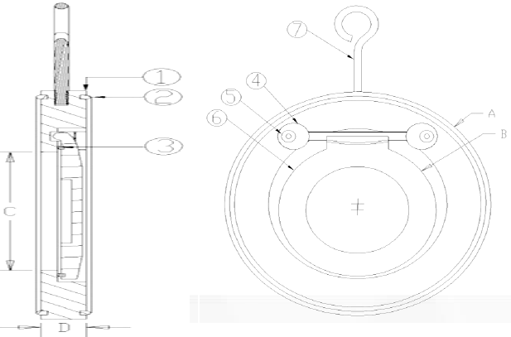

**Specification & Features-**

* Easily Installed
* Light Weight
* Tight Shut-off
* Economical
* Interchangeable Disc
* Low Maintenance

**Working Temp.: 20 C to 200 C**

**Working Pr.: 500 PSG Hyd.**

**Part Name:- Size / Dimension:-**

|  |  |  |  |  |  |  |  |  |
| --- | --- | --- | --- | --- | --- | --- | --- | --- |
| **No.** | **Part Name** | **Material** |  | **Size** | **A** | **B** | **C** | **D** |
| **01** | **Body** | **WCB / CF8 / CF8M** |  | **40** | **86** | **32** | **22** | **19** |
| **02** | **Outer Ring** | **EPDM** |  | **50** | **97** | **41** | **30** | **19** |
| **03** | **Inner Ring** | **EPDM** |  | **65** | **110** | **50** | **40** | **19** |
| **04** | **Allen key** | **MS / SS** |  | **80** | **130** | **62** | **50** | **19** |
| **05** | **Disc** | **WCB / CF8 / CF8M** |  | **100** | **160** | **84** | **70** | **19** |
| **06** | **I-Bolt** | **MS** |  | **125** | **192** | **107** | **92** | **19** |
|  |  |  |  | **150** | **216** | **128** | **112** | **19** |
|  |  |  |  | **200** | **273** | **172** | **157** | **28** |
|  |  |  |  | **250** | **336** | **213** | **195** | **28** |
|  |  |  |  | **300** | **385** | **250** | **230** | **38** |
|  |  |  |  | **350** | **445** | **310** | **275** | **40** |
|  |  |  |  | **400** | **496** | **352** | **320** | **40** |

**Due to continuous development Program, the design & data given in this leaflet are subject to change without prior notice.**

**ANITA ENGINEERING WORKS**



58-59, Narayan Estate, Opp. Shree Ram Estate, Nr. CMC Ltd. Odhav, Ahmedabad-382415, Gujarat, India

Phone: +91 79 22974101, Fax: +91 79 22875014

Email: eascovalves@gmail.com, eascovalves@yahoo.com, Web: [www.eascovalve.com](http://www.eascovalve.com)

